Balch Field Common Rules

- Fair/Foul: as marked by the chalk lines. Fair/Foul lines will line up with the fence posts in Left and Right field that contain the distance sign.
- In Play/Out of Play:
  - 1st Base side: Inside the fence is in play
  - 3rd Base side: Straight line from the end of the dugout fence closest to the field to the beginning of the batting nets next to left field. Behind that line is out of play. The nets and the space between the nets and outfield fence are out of play.
- Overthrows:
  - At 1st Base:
    - Ball is live if it lands in front of or hits the dugout fence. No automatic bases given to runners.
    - Ball is dead if the overthrow goes over the fence or past the open end of the dugout fence (toward Right field), including the opening between the dugout and Right field fences. 1 base is automatically awarded to each runner from the last base they touched.
  - At 3rd Base:
    - Ball is live if it lands in front of or hits the dugout fence. No automatic bases given to runners.
    - Ball is dead if the overthrow goes over the fence or past the open end of the dugout fence (toward Left field). 1 base is automatically awarded to each runner from the last base they touched.
- Collapse Rule:
  - Outfields can collapse to the first cone. A general suggestion would be to place that cone about 60 feet, or roughly 25 steps, from 1st or 3rd Base.
- Commit Line:
  - No commit line between 3rd and Home.
- Home Runs:
  - From Left field to Center field, anything over the fence counts. No home run limit.
    - If the ball lands in the exit opening in Left-Center field, it will be a ground rule double.
  - From the light pole in Right-Center field to Right field, home runs are limited to 3 per team, per game.
    - Home runs hit to Right field after the limit will be an out.
    - A ball that hits the light pole does not count toward the limit.

Coakley Field Common Rules
- Fair/Foul: as marked by the chalk lines.
  - The Fair/Foul line along the 1st Base side will line up with the field goal post along Right field that has a single support pole coming out of the ground – that single support pole will mark the end of the foul line. If a ball hits the field goal, it is in play. If a ball hits any part of that field goal in the air, it will be a home run.
  - The Fair/Foul line along the 3rd Base side will line up with the right-most pole of the baseball field’s backstop.
- In Play/Out of Play:
  - 1st Base side: Because of the bleachers, there is very little safe out-of-bounds space. Draw a straight line along the front of the first bleacher bench. Anything behind that bleacher bench is out of play.
  - 3rd Base side: The walking path will mark the in-play area along 3rd Base. The path is out of play. The space between the path and the 3rd Base line is in play. Any contact with the field goal in left field is out of play / dead ball.
- Overthrows:
  - At 1st Base:
    - Ball is automatically dead on any overthrow (because of the bleachers being close by). 1 base is automatically awarded to each runner from the last base they touched.
  - At 3rd Base:
    - Ball is live if it stays inside the walking path. No automatic bases given to runners.
    - Ball is dead if the overthrow goes onto or past the walking path. 1 base is automatically awarded to each runner from the last base they touched.
- Collapse Rule:
  - Outfields can collapse to the first cone. A general suggestion would be to place that cone about 60 feet, or roughly 25 steps, from 1st or 3rd Base.
- Commit Line:
  - No commit line between 3rd and Home.
- Home Runs:
  - Anything over the fence counts. No home run limit.
  - In Left field, where there is no fence, there is a walking path just past the grass. That walking path will act as a fence. A ball that lands on the path or beyond in the air will be a home run. A ball that rolls onto or past the path will be out of play, and a ground rule triple. A ball out of play cannot be caught.
  - In Right field, where there is no fence, draw a line between the foul pole (the support pole of the field goal) and the end post of the fence in Right field. That line will mark the field of play. A ball hit over that line in the air is a home run. A ball that rolls past that line will be out play and a ground rule triple. A ball out of play cannot be caught. If possible, mark this line with cones.
First Base Line: 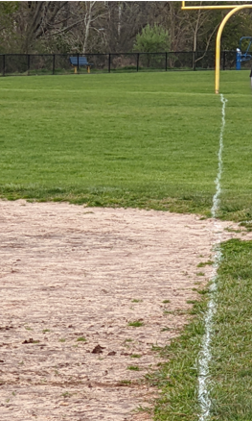 Third Base Line: 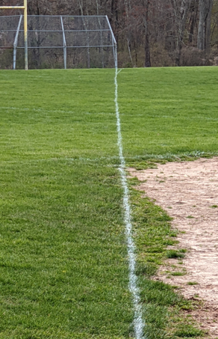
Memorial Field Common Rules

- Fair/Foul: as marked by the chalk lines. Fair/Foul lines will line up with the fence posts in Left and Right field that contain the distance sign.
- In Play/Out of Play:
  - 1st Base side: Inside the fence is in play
  - 3rd Base side: Straight line from the end of the dugout fence closest to the field to the beginning of the batting nets next to left field. Behind that line is out of play. The nets and the space between the nets and outfield fence are out of play.
- Overthrows:
  - At 1st Base:
    - Ball is live if it lands in front of or hits the dugout fence. No automatic bases given to runners.
    - Ball is dead if the overthrow goes over the fence or past the open end of the dugout fence (toward Right field), including the opening between the dugout and Right field fences. 1 base is automatically awarded to each runner from the last base they touched.
  - At 3rd Base:
    - Ball is live if it lands in front of or hits the dugout fence. No automatic bases given to runners.
    - Ball is dead if the overthrow goes over the fence or past the open end of the dugout fence (toward Left field). 1 base is automatically awarded to each runner from the last base they touched.
- Collapse Rule:
  - Outfields can collapse to the first cone. A general suggestion would be to place that cone about 60 feet, or roughly 25 steps, from 1st or 3rd Base.
- Commit Line:
  - No commit line between 3rd and Home.
- Home Runs:
  - From Left field to Center field, anything over the fence counts. No home run limit.
    - If the ball lands in the exit opening in Left-Center field, it will be a ground rule double.

